Thames Valley Environmental Records Centre (TVERC) would like to learn more about the people who observe wildlife in this part of South Oxfordshire and West Berkshire. For the specific area of interest, kindly refer to the project area map provided below in section 1 or click here <https://tinyurl.com/y4ddcv9y> to download. The project area includes the area within the Mend the Gap boundary and a surrounding 5km buffer.

**If you spot wildlife within the Mend the Gap boundary or its surrounding 5km buffer, as a hobby, or just as part of your everyday life, we would appreciate your feedback.**

There is a national shortage of wildlife identification skills, particularly in the younger population, and this survey will help us better understand who is currently spotting wildlife in this area, and what training, and support, might be beneficial to them.

This survey is funded by the Mend the Gap (MTG) programme, a joint programme of the Chilterns and North Wessex Downs National Landscapes, and the Railway Action Group. The vision of Mend the Gap is that the outstanding national landscape that links the Chilterns and the North Wessex Downs will be enhanced and enriched for wildlife, residents and visitors. To find out more visit [www.mendthegap.uk](http://www.mendthegap.uk) or follow [www.facebook.com/MendtheGapProgramme](http://www.facebook.com/MendtheGapProgramme)

The survey should take around 10 to 15 minutes to complete. Please note that the survey will be **open for responses until September 30, 2024.**

Thank you for taking the time to fill out the form.  Thames Valley Environmental Records Centre, www.tverc.org, [tverc@oxfordshire.gov.uk](mailto:tverc@oxfordshire.gov.uk)

Disclaimer

The results of this survey will be used for the purposes of the Mend The Gap Wildlife Sightings Project, which will be made public by TVERC and MTG.

No personally identifiable information will be published by TVERC or shared with any other party.

If you provide your email address, and give consent for TVERC to contact you, we will only contact you regarding this survey.

Answers to the following questions will be used for analytical purposes, and to inform possible future project work

* Required

**Mend the Gap Project Area**

**(includes a 5km buffer from the MTG boundary)**

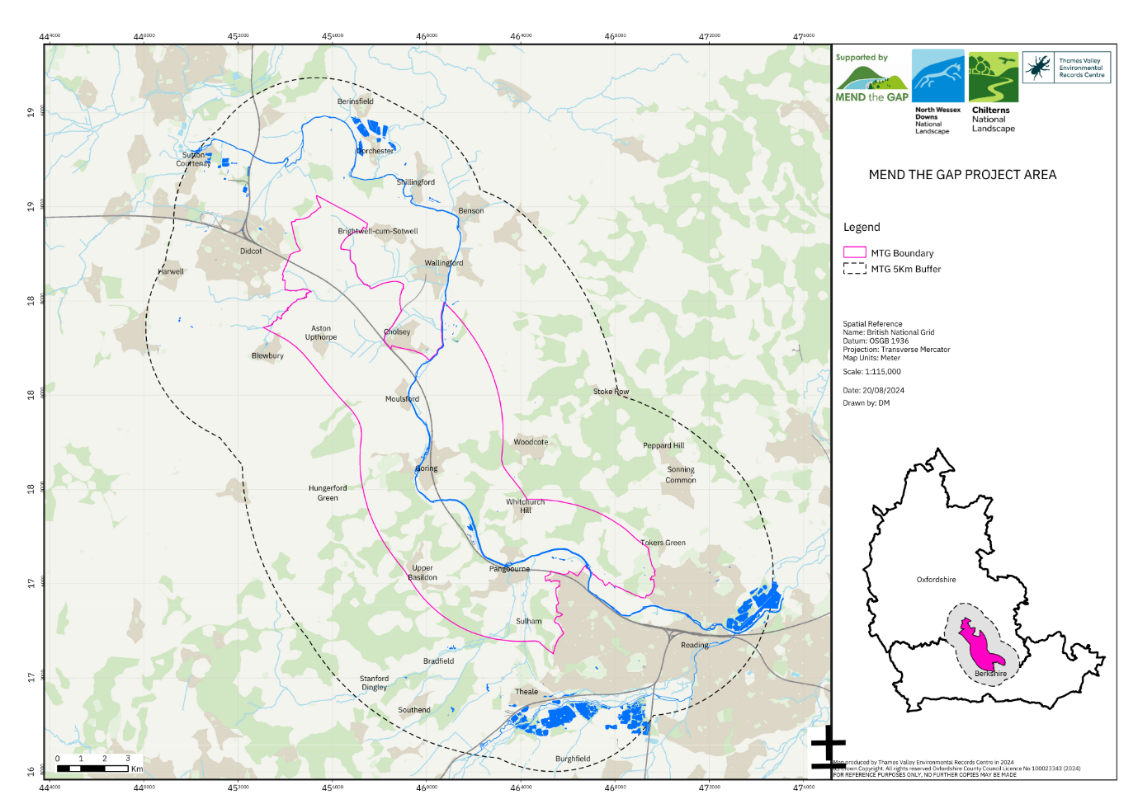

1. **Name – optional:**

**Demographic Questions**

1. Where do you live? - please provide the first part of your postcode e.g. OX10 *
2. Please select the category that includes your age: *

Under 18

18 – 24

25 – 34

35 – 44

45 – 54

55 – 64

65 or above

Prefer not to say

1. Which gender do you identify most with? *

Female

Male

Other

Prefer not to say

1. Which gender do you identify most with? *

Yes

No

Prefer not to say

1. What is your main language? *

English

Other

Prefer not to say

1. What is your ethnic group? *

White

Mixed or multiple ethnic groups

Asian of Asian British

Black, Black British, Caribbean or African

Prefer not to say

Other Click or tap here to enter text.

1. Please record any qualifications you have ever achieved in the UK or abroad, even if you are not using them now. Tick all that apply. *

No formal qualifications

GCSE’s or equivalent qualifications

Two or more A Levels or equivalent qualifications

Higher National Certificate, Higher National Diploma, Bachelor’s degree, or post-graduate qualifications

Apprenticeship

Prefer not to say

Other Click or tap here to enter text.

1. What is your current employment status?  *

Full-time employment

Part-time employment

Unemployed

Self-employed

Looking after home or family

Student

Retired

Prefer not to say

Other Click or tap here to enter text.

1. Are you currently in receipt of Universal Credit? *

Yes

No

Prefer not to say

1. How many people live in your household, including you? *

1

2

3

4

5 or more

Prefer not to say

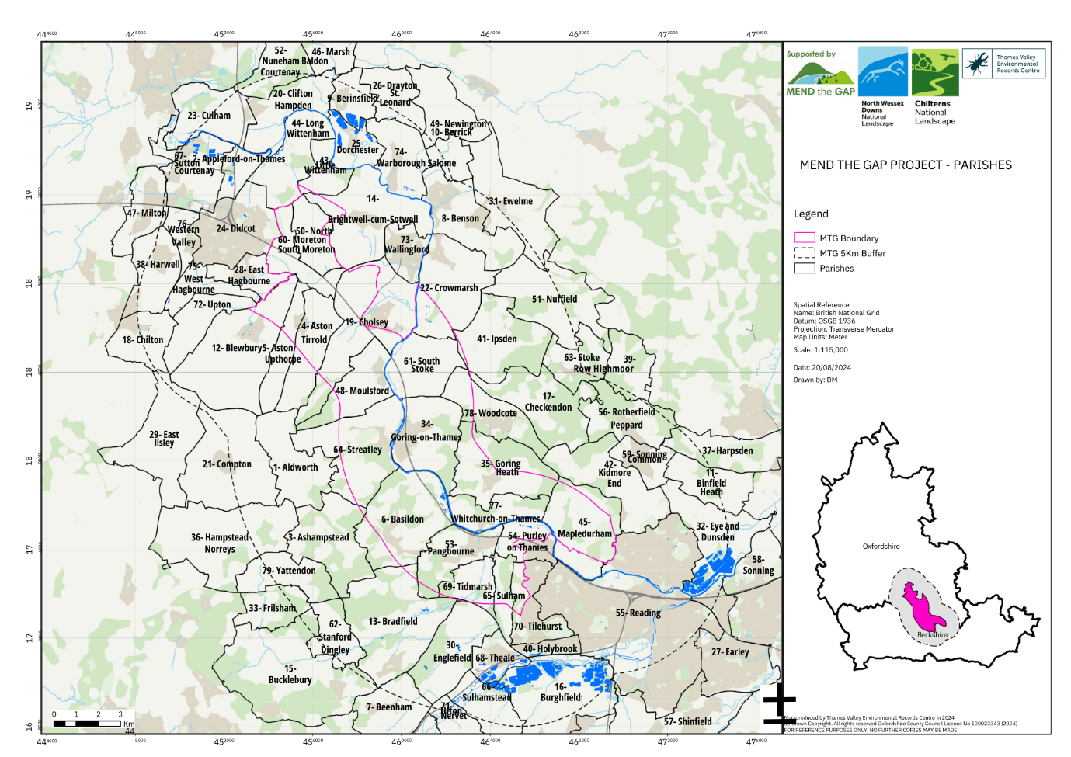**Wildlife Sightings Questions**

1. Where do you make *wildlife sightings in the Mend the Gap area?

**For Parish options please see the Parishes map above in section 3, or you can download it here https://tinyurl.com/33caj76m. Alternatively, please see the Parishes table below. Please state all Parishes that apply, using numbers or names.** *\*For this survey, 'wildlife sighting' means any time when you observe wildlife in a way that would allow you to identify them, whether from your garden, on a walk, or a dedicated outing’*

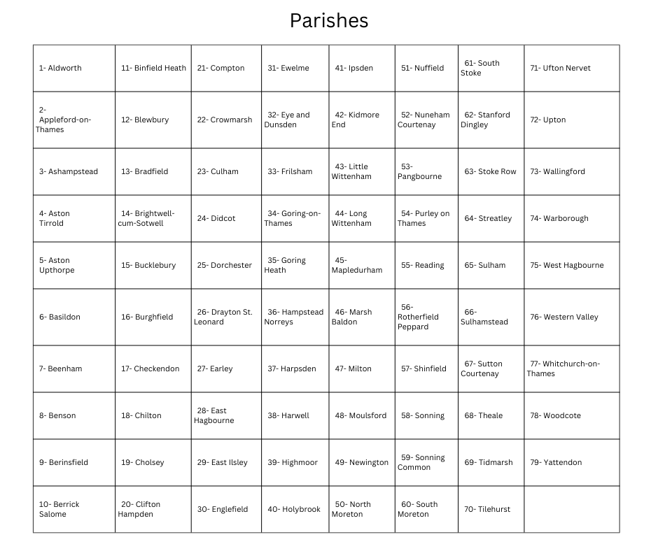

1. How do you travel to where you make wildlife sightings? Please tick all that apply.

Walk

Bicycle

Bus

Train

Own vehicle

Someone else’s vehicle

I don’t; it’s my garden

Other Click or tap here to enter text.

1. What wildlife groups do you observe? Please tick all that apply. *

Amphibians

Beetles

Birds

Butterflies

Damselflies

Dragonflies

Flies

Flowering plants (non trees)

General invertebrates

Lower plant (byrophytes, mosses, liverworts, lichens, fungi and algae)

Mammals

Moths

Molluscs

Reptiles

Trees

Other

1. How would you describe your wildlife identification skills of the following groups? **Please give a rating for all.**

(0 = no experience, 1 = I observe this animal or plant but am not able to identify it 5 = I can confidently identify the animal or plant I have observed)

|  |  |  |  |  |  |  |
| --- | --- | --- | --- | --- | --- | --- |
|  | **0** | **1** | **2** | **3** | **4** | **5** |
| **Amphibians** |  |  |  |  |  |  |
| **Beetles** |  |  |  |  |  |  |
| **Birds** |  |  |  |  |  |  |
| **Butterflies** |  |  |  |  |  |  |
| **Damselflies** |  |  |  |  |  |  |
| **Dragonflies** |  |  |  |  |  |  |
| **Flies** |  |  |  |  |  |  |
| **Flowering plants (non trees)** |  |  |  |  |  |  |
| **General Invertebrates** |  |  |  |  |  |  |
| **Lower plants** |  |  |  |  |  |  |
| **Mammals** |  |  |  |  |  |  |
| **Molluscs** |  |  |  |  |  |  |
| **Moths** |  |  |  |  |  |  |
| **Reptiles** |  |  |  |  |  |  |
| **Trees** |  |  |  |  |  |  |

1. How often are you making wildlife sightings?

Daily

Weekly

Monthly

Seasonally

When recording schemes happen

Ad hoc

I don’t know

Other Click or tap here to enter text.

1. Why do you make wildlife sightings? Please tick all that apply. For 'other', please specify.

As part of my work

As part of local recording schemes

As part of national recording schemes

Personal interest

To inform decisions in development or protecting sites

Other Click or tap here to enter text.

1. Who do you share your wildlife sightings with? Please tick all that apply.

TVERC

iRecord

iNaturalist

Local group

Recording scheme(s)

I don’t

Other Click or tap here to enter text.

1. Could you tell us the reasons why you might not share your wildlife sightings? Please tick all that apply. For 'other', please specify.

I don’t have time

I don’t know how to share them e.g what format

I don’t know who to share my wildlife sightings with

Lack of confidence in how my sightings will be used

Lack of access to digital resources e.g. Computer, Phone Apps

I hadn’t thought about sharing them

I would prefer not to share them

Other Click or tap here to enter text.

1. Are there any wildlife groups you would like to make sightings for, that you currently don't? Please tick all that apply.

☐ Amphibians

☐ Beetles

☐ Birds

☐ Butterflies

☐ Damselflies

☐ Dragonflies

☐ Flies

☐ Flowering plants (non trees)

☐ General invertebrates

☐ Lower plant (byrophytes, mosses, liverworts, lichens, fungi and algae)

☐ Mammals

☐ Moths

☐ Molluscs

☐ Reptiles

☐Trees

☐ Other Click or tap here to enter text.

1. What support do you think would be useful for people making wildlife sightings?

Training in identifying wildlife

Training in how to share their sightings

Advice about who can help

Printed forms to add sightings to

Mentors

Equipment

Connecting with other people

Other Click or tap here to enter text.

1. What do you think are the barriers that might prevent more people from participating in wildlife recording? e.g. time, travel, costs, health.

**Thank you for taking the time to complete this survey.**

If you have any questions, please contact Thames Valley Environmental Records Centre

www.tverc.org [tverc@oxfordshire.gov.uk](mailto:tverc@oxfordshire.gov.uk)

1. Are you happy for TVERC to contact you about this survey? We will not share your details with anyone else.

☐ Yes

☐ No

1. If yes, please provide an email address

Click or tap here to enter text.